Hands on 1

Name:- Shubham Sangram Bej

React-JS HOL

Objective
To install the React development environment, create a React application using Create React App, and display a simple heading in the browser.

Software Requirements
- Node.js
- npm
- Visual Studio Code
- React
- Create React App

Procedure
- Installed Node.js and npm.
- Created a new React application using:
npx create-react-app myfirstreact
- Opened the project in Visual Studio Code.
- Modified the App.js file.
- Executed the project using:
npm start
- Verified the output in the browser.

App.js
function App() {
return (
<div>
<h1>Welcome to the first session of React</h1>
<h2>Hi!! My name is Shubham Sangram Bej</h2>
</div>
);
}

export default App;

Output
The browser successfully displayed:
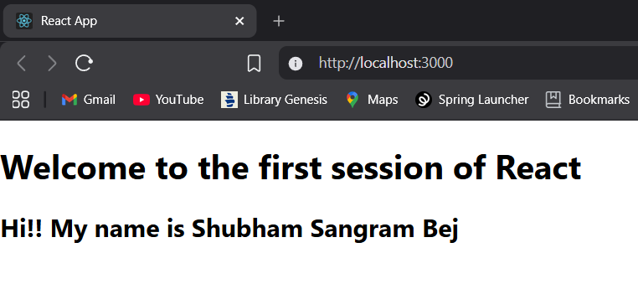
confirming that the React application was created and executed successfully.

Result
The React application was successfully created using Create React App, and the required heading was displayed in the browser.

